**Aim:- Implementation of Classification algorithm in R-Programming.**

1. **Open Rstudio. Open File and Click on New File Then Click on R script.**

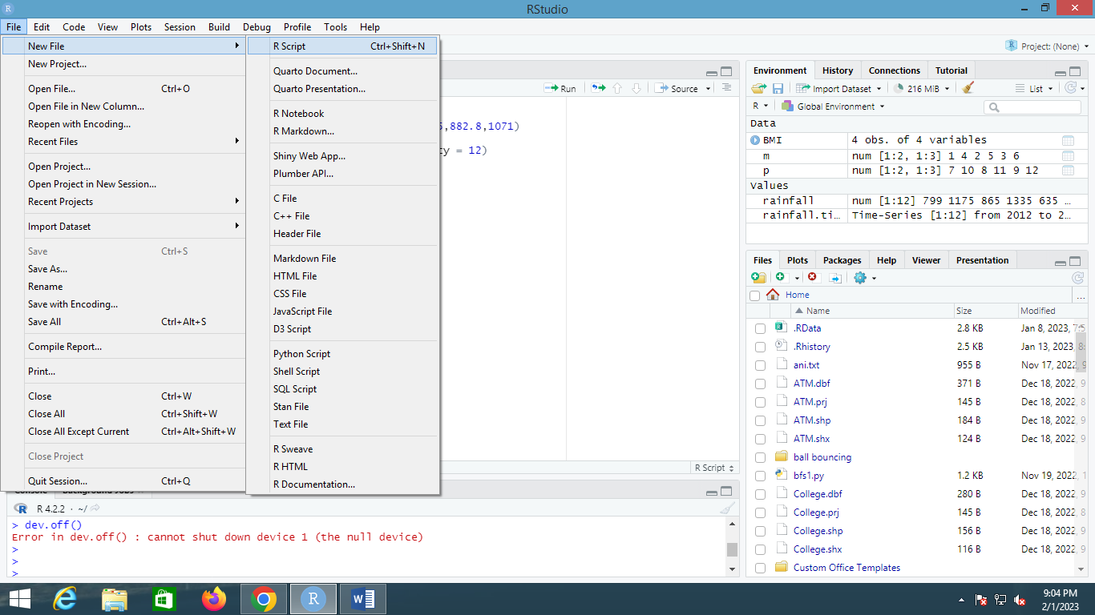

1. **Type the code And save it.**

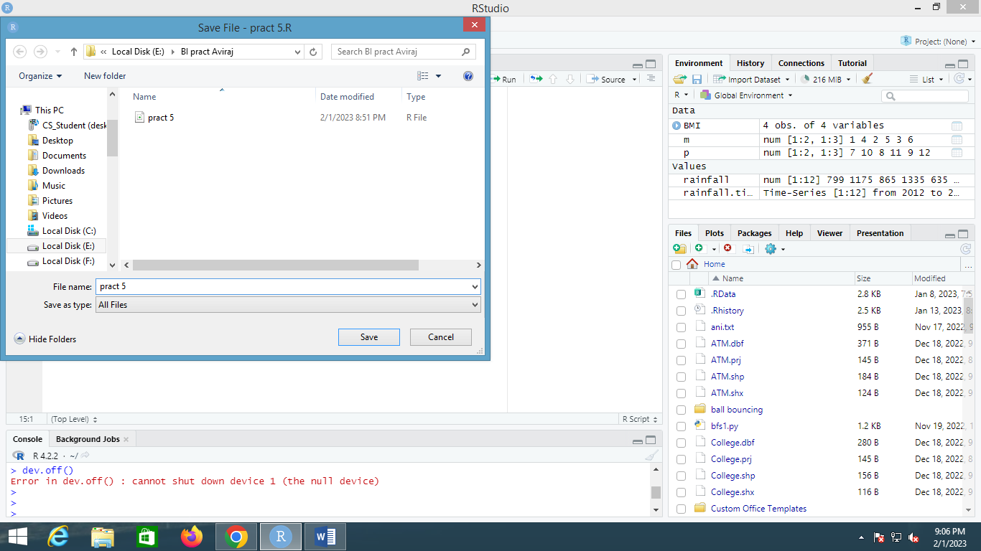

1. **Then Click on Source.**

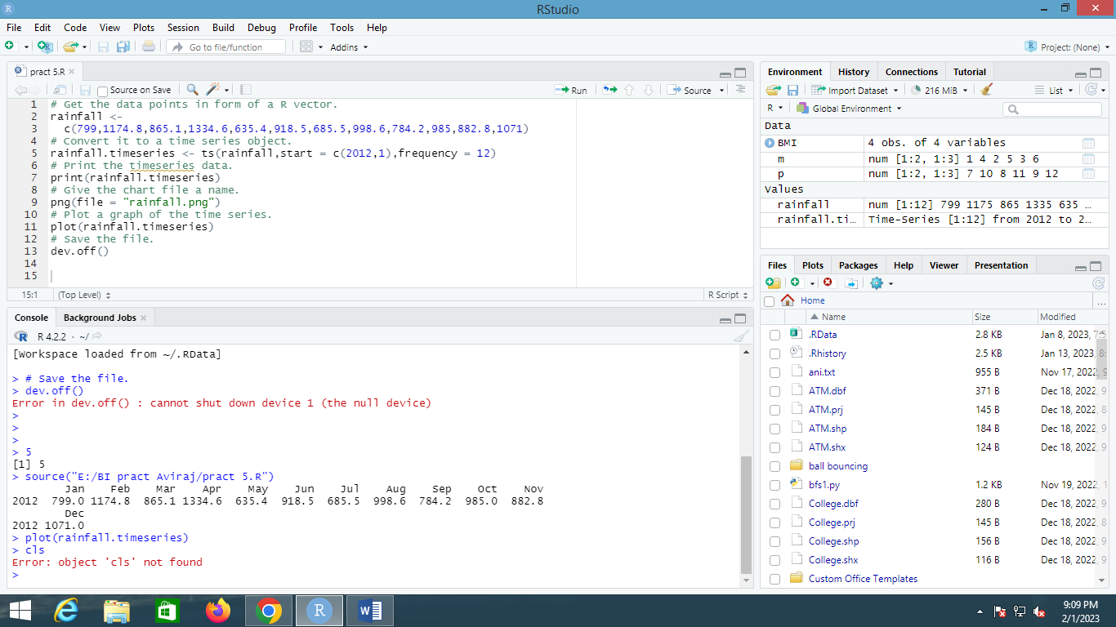

1. **Then Type plot(rainfall.timeseries) in Console.**



1. **Then Click on Plot.**

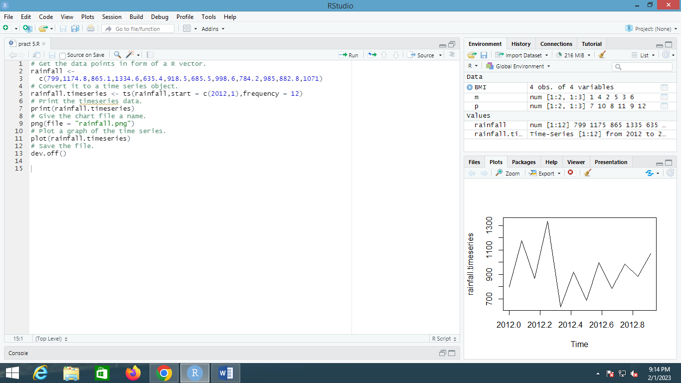

1. **Code:-**

# Get the data points in form of a R vector.

rainfall <-

c(799,1174.8,865.1,1334.6,635.4,918.5,685.5,998.6,784.2,985,882.8,1071)

# Convert it to a time series object.

rainfall.timeseries <- ts(rainfall,start = c(2012,1),frequency = 12)

# Print the timeseries data.

print(rainfall.timeseries)

# Give the chart file a name.

png(file = "rainfall.png")

# Plot a graph of the time series.

plot(rainfall.timeseries)

# Save the file.

dev.off()

**Output:- Plot**

